**FORENSIC FLOW: A DETAILED ANALYSIS OF CRIME SCENE USING MACHINE LEARNING**

|  |  |  |
| --- | --- | --- |
|  |  |  |
| Dr. K. Venkatesh  *Department of Computer Science*  *and Engineering*  *Kalasalingam Academy of*  *Research and Education,*  *Krishnankoil, Virudhunagar,*  *India*  *k.venkatesh@klu.ac.in* | K. Hitesh Kumar  *Department of Computer Science and Engineering*  *Kalasalingam Academy of*  *Research and Education,*  *Krishnankoil, Virudhunagar,*  *India*  *99220040586@klu.ac.in* | M. Krishna Sairam  *Department of Computer Science*  *and Engineering*  *Kalasalingam Academy of*  *Research and Education,*  *Krishnankoil, Virudhunagar.*  *India*  *99220040588@klu.ac.in* |
| M. Santhosh Kumar  *Department of Computer Science*  *and Engineering*  *Kalasalingam Academy of*  *Research and Education,*  *Krishnankoil, Virudhunagar,*  *India*  *99220040115@klu.ac.in* | M. Anil Kumar  *Department of Computer Science*  *and Engineering*  *Kalasalingam Academy of*  *Research and Education,*  *Krishnankoil, Virudhunagar,*  *India*  *99220040113@klu.ac.in* |  |

***Abstract*- Forensic Fusion is an automated crime scene analysis system with an advanced machine learning algorithm that thoroughly examines visual evidence. This technology is enhanced with YOLO object detection in order to extract and label important areas of the crime scene in an accurate manner. As it integrates with the Forensic Flow platform, the system ensures secure evidence manipulation and preservation of the evidence. With the help of object detection logs and graphic illustrations, a diverse range of reports is compiled by the module. Such automation enhances efficiency in forensic analysis whilst reducing the duration of the inquiry. SDG 9: Infrastructure, Industry and Innovation & SDG 16: Justice, Peace and Strong Institutions Legal institutions are interconnected in the context of forensic technologies. The development of these technologies in the justice systems is contributed by the employment of machine learning, digital forensics, and other advanced technologies in crime scene investigations making them more effective and trustworthy. Such innovations provide both timely and accurate evidence for investigations thus reinforcing both legal and law enforcement systems. By developing new forensic methods that improve security and resilience of justice systems in communities, these goals promote peace, justice and strong institutions.**

**Keywords:** Machine Learning Forensics, YOLO Object Detection, Automated Crime Scene Analysis, Digital Evidence Processing, Forensic Image Recognition, Criminal Investigation Technology, ForensicFlow Integration, Real-time Evidence Detection, Computer Vision in Forensics, Automated Forensic Reporting, Infrastructure, Industry,

and Innovation, Peace, Justice, and Strong Institutions

**1.Introduction**

The combination of machine learning and artificial intelligence is revolutionizing criminal investigations. Forensic Fusion presents a novel system that automates crime scene analysis by fusing conventional forensic techniques with YOLO (You Only Look Once) item detection algorithms. With its smooth integration with Forensic Flow, the system automatically recognizes and categorizes important evidence while guaranteeing safe data management and evidence integrity [1]. Forensic Fusion gives investigators clear, useful information by producing thorough reports with in-depth object detection logs and annotated visualizations. This technology transforms the way law enforcement organizations conduct crime scene investigations by drastically cutting down on investigation time and improving forensic analysis accuracy.

# 2. Overview of ForensicFlow

A major development in criminal investigation technology is forensic fusion, which combines conventional forensic techniques with artificial intelligence. The fundamental operation of the system is based on YOLO object detection algorithms, which expedite the investigation by automatically locating and categorising important evidence within crime scenes. With features like role-based access control and zero-trust security frameworks, the platform offers secure data handling and evidence integrity through a smooth connection with ForensicFlow. To give investigators useful information, the system creates thorough reports that include item detection logs, annotated visualisations, and thorough case summaries. These automated procedures improve forensic analysis accuracy while drastically cutting down on inquiry time. Forensic Fusion is a game-changing technology for contemporary law enforcement organisations because of its strong security features and sophisticated machine learning capabilities.

# 3. Tools Integrated into ForensicFlow

# 3.1. FTK Imager

FTK Imager is a widely recognized tool in the digital forensics community, designed for creating forensic images of data and enabling detailed data analysis. It allows investigators to create exact bit-by-bit copies of hard drives, USB drives, and other digital media, ensuring that the original evidence remains intact and unaltered. FTK Imager provides a range of functionalities, including file preview, data carving, and the ability to analyze various file systems. Its user-friendly interface makes it accessible to both novice and experienced investigators. In practical applications, FTK Imager has been utilized in numerous investigations, helping law enforcement agencies recover deleted files, uncover hidden data, and maintain the chain of custody throughout the forensic process. Despite its strengths, FTK Imager faces challenges, including potential compatibility issues with certain file systems and limitations in handling encrypted data, which investigators must navigate during forensic analysis.

**3.2. Autopsy**

Autopsy is an open-source digital forensics platform that provides a comprehensive suite of tools for forensic investigators. It offers functionalities for file analysis, timeline analysis, keyword searching, and social network analysis, enabling investigators to piece together critical information from digital evidence. Autopsy’s modular architecture allows users to customize their workflow by integrating various plugins and extensions to enhance functionality. It excels in examining large datasets, enabling investigators to identify connections and relationships within the data that may be vital to their cases. Real-world applications of Autopsy include investigations into cybercrime, child exploitation, and corporate fraud, where its capabilities have proven instrumental in uncovering evidence. However, while Autopsy is powerful, it may require a learning curve for users new to digital forensics, necessitating thorough training and familiarization with its extensive features.

**3.3. Email Header Analysis**

Email header analysis is a critical component of digital forensics, as it provides vital information regarding the origin, route, and destination of email communications. Analyzing email headers allows forensic investigators to identify the sender’s IP address, determine the email server’s path, and uncover timestamps associated with the email’s transmission. Tools such as Email Header Analyzer and MxToolbox facilitate this process by parsing and interpreting complex header information, making it accessible for analysis. In forensic investigations, email header analysis can play a pivotal role in establishing timelines, identifying potential suspects, and gathering evidence in cases such as fraud, harassment, and other cybercrimes. Numerous case studies demonstrate the effectiveness of email header analysis, where investigators successfully traced malicious communications and built compelling cases against perpetrators. However, investigators must remain vigilant about the potential for spoofed headers and the challenges presented by encrypted emails.

**3.4. Test Disk**

TestDisk is a powerful open-source data recovery tool that plays a crucial role in digital forensics by recovering lost partitions and restoring damaged files. It is particularly effective for situations where hard drives become corrupted or partitions are inadvertently deleted. TestDisk operates by scanning the drive to identify existing partitions and utilizing various algorithms to recover lost data. Its intuitive command-line interface, combined with robust recovery capabilities, makes it a valuable asset for forensic investigators tasked with data recovery. Use cases for TestDisk include the recovery of critical evidence from damaged storage devices, making it an essential tool in investigations where data integrity is paramount. However, its reliance on user knowledge and experience in operating command-line tools can be a limitation for some investigators, emphasizing the importance of training and familiarity with data recovery processes.

**3.4. Forensic Fusion.**

YOLO (You Only Look Once): Object detection model that will analyze images or video frames to identify crime scene objects like weapons, vehicles, or other pertinent items. Object Detection and Classification: YOLO can provide classifications and bounding boxes for the detected objects. This flags items of forensic interest. Detailed Reporting: Reports automatically will be generated summarizing findings, highlighting detected objects, locations, timestamps, and contextual data useful for investigation.

Within the Forensic Fusion system, YOLO (You Only Look Once) is a revolutionary method for real-time object detection. YOLO is incredibly quick and effective because it scans the entire image in a single forward pass through its neural network, as opposed to typical computer vision techniques that scan images several times. To produce precise item detections, the system divides images into a grid, applies confidence scores, and forecasts bounding boxes and class probabilities for each grid cell. This entails the quick identification of vital evidence in forensic applications, including tools, weapons, footprints, and other pertinent items, with each detection supported by exact spatial coordinates and confidence ratings.

To improve the detection accuracy of crime scene items, YOLO is implemented in Forensic Fusion using transfer learning and bespoke training on forensic-specific datasets. Convolutional neural networks (CNNs) are used in the model's hierarchical feature extraction method to recognise both general objects and particular forensic markers. This sophisticated capability enables the detection of minor evidence, such as partial fingerprints, trace evidence, or pattern marks, that could be missed during manual examination. The system is a vital tool for contemporary forensic inquiry because of its high accuracy rates and real-time processing of several picture formats and video streams.

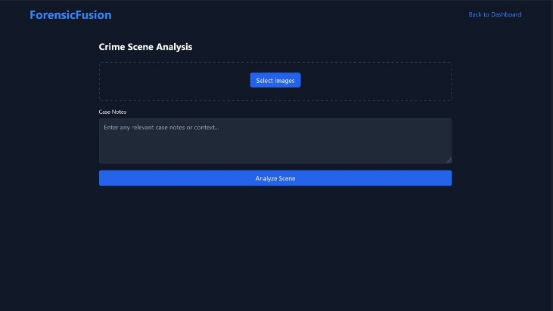

**Figure 1:**  Forensic Fusion

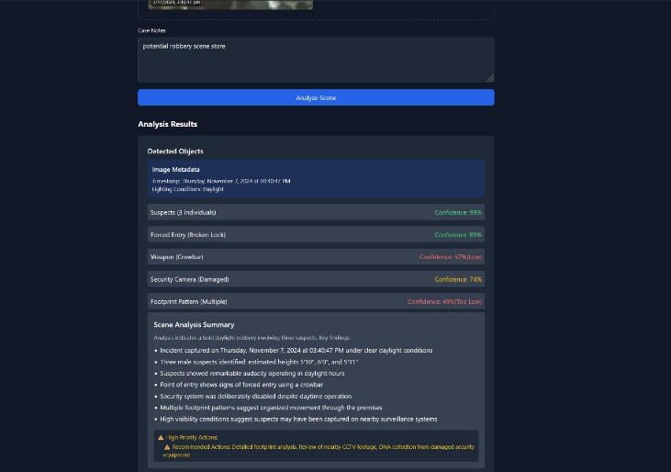

**Figure 3:**  Post-Analysis Output of forensic fusion

# 4. Security Mechanisms in ForensicFlow

**4.1. Role Based Access Control (RBAC)**

Role-Based Access Control is a security mechanism in which the system's access is limited to users based on roles within the organization. Within digital forensics, protection of sensitive data is especially crucial where maintaining the integrity needed for forensic investigations is important. The concept of permission based on a given user role reduces unauthorized access and modification of data since only the ones granted the permission can even view or modify the evidence. An implementation of RBAC such as ForensicFlow is helpful to an organization regarding the efficient managing of access while providing a clear audit trail of access, looking at who accessed what data at what time. This approach enhances accountability and helps preserve the chain of custody, which is vital in legal proceedings. Case studies reveal that organizations employing RBAC have significantly reduced the risk of insider threats and data breaches, reinforcing the importance of access control in forensic investigations

**4.2. Zero Trust Network.**

The Zero Trust Network model is predicated on the principle of "never trust, always verify," emphasizing the need for continuous authentication and monitoring of users and devices. In digital forensics, implementing a Zero Trust Network is critical to safeguarding sensitive data and forensic evidence from cyber threats. This security framework mandates verification of every user and device attempting to access the system, regardless of whether they are inside or outside the network perimeter. ForensicFlow adopts Zero Trust principles to ensure that all access requests are authenticated and that monitoring occurs at all stages of the forensic process. This approach not only strengthens the security posture of forensic investigations but also minimizes the risk of data breaches and unauthorized access. As cyber threats become increasingly sophisticated, the adoption of Zero Trust principles is becoming essential for organizations involved in digital forensics.

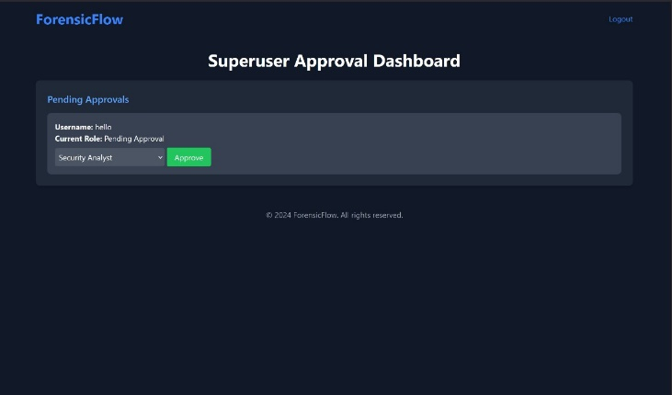

**Figure 2:**  Zero Trust Network

**4.2. Least Privilege Access**

The Least Privilege Access principle is a fundamental security measure that grants users the minimum level of access necessary to perform their duties. In forensic investigations, implementing least privilege access helps mitigate risks associated with data exposure and unauthorized manipulation of forensic evidence. ForensicFlow incorporates this principle by ensuring that users are granted access only to the specific tools and data necessary for their roles, thereby reducing the attack surface and potential vulnerabilities. By limiting access, organizations can enhance the overall security of their forensic processes and maintain the integrity of digital evidence. The benefits of least privilege access are well-documented, with studies indicating a significant reduction in security incidents and data breaches within organizations that adopt this approach.

**4.2. OWASP Top-10**

OWASP Top 10 refers basically to a list of highly recognized most serious security vulnerabilities in web applications. In ForensicFlow, the knowledge and mitigation of these vulnerabilities would best secure the platform and the data it would hold. Examples include risks such as injection attacks, broken authentication, sensitive data exposure, and security misconfiguration. By adhering to OWASP guidelines, ForensicFlow incorporates best practices for securing its applications and ensuring the confidentiality, integrity, and availability of digital evidence. Organizations utilizing ForensicFlow are encouraged to conduct regular security assessments and penetration testing to identify and address vulnerabilities, thus strengthening their overall security posture. Case studies illustrate the importance of addressing OWASP Top 10 vulnerabilities, demonstrating how proactive measures can prevent security incidents and protect sensitive forensic data.

**4.2. Containerization**

To guarantee total isolation and protection of crime scene data, Forensic Fusion uses cutting-edge containerization technology as a crucial security measure. Every inquiry is contained within a separate, safe container, forming an impenetrable barrier that stops any unapproved entry or cross-contamination between cases. By using Docker and Kubernetes orchestration, this containerization technique creates separate runtime environments with their own filesystems, network spaces, and dedicated resources. Because of the system's stringent access controls, data from various cases is kept entirely separate and only accessible by authorized people with certain case-level permissions, even within the same organization**.**

Multiple levels of security enforcement are offered by the containerized architecture [2]. Data leaking across cases is technically impossible because each container has its own separated network stack, dedicated memory space, and encrypted storage. The system uses immutable containers, which guarantee the integrity of the evidence by preventing changes to the container's underlying configuration once it has been constructed for a case. All container operations are also recorded and tracked in real time, with automated notifications sent out in the event of any illegal access attempts or attempts at cross-container communication. Because of its strong security approach, Forensic Fusion is especially well-suited to managing delicate forensic data while strictly adhering to chain of custody regulations.

# 5.Case Study and Applications

Real-world applications of ForensicFlow highlight its effectiveness in streamlining digital forensic investigations. One notable case involved a law enforcement agency investigating a complex cybercrime ring responsible for identity theft and financial fraud. Utilizing ForensicFlow, investigators were able to integrate multiple forensic tools, including FTK Imager and Autopsy, to quickly analyze data from various sources, including hard drives and cloud storage. The automation features of ForensicFlow allowed investigators to rapidly identify patterns and connections within the data, leading to the successful identification of suspects and the recovery of stolen funds. Another case study focused on a corporate investigation into insider threats, where ForensicFlow’s security mechanisms, such as RBAC and Zero Trust principles, ensured that sensitive data remained protected while allowing authorized personnel to conduct thorough analyses. These examples demonstrate the potential of ForensicFlow to enhance the efficiency and effectiveness of digital forensic investigations, ultimately leading to more successful outcomes.

# 6. Challenges and Limitaions

While ForensicFlow offers significant advancements in automated digital evidence analysis, several challenges and limitations must be considered. One of the primary challenges is the rapid evolution of technology and cybercrime tactics. As cybercriminals adopt more sophisticated methods to obfuscate their activities, forensic tools must continually adapt to keep pace. This necessitates ongoing development and updates to the tools integrated within ForensicFlow to ensure they remain effective against new threats.

Another limitation is the potential for false positives and false negatives in automated analysis. Although automation increases efficiency, it can also lead to overlooking critical evidence or misidentifying innocent data as malicious. Therefore, human oversight remains essential in the forensic process to validate automated findings and make informed decisions based on context.

Data privacy and compliance with regulations, such as the General Data Protection Regulation (GDPR), also present challenges. Forensic investigators must navigate legal and ethical considerations while collecting and analyzing data, ensuring that they respect individuals' privacy rights and adhere to applicable laws.

Finally, the learning curve associated with using advanced forensic tools can hinder widespread adoption. Investigators may require extensive training to effectively leverage the capabilities of ForensicFlow, particularly if they are unfamiliar with the integrated tools. Therefore, organizations must invest in training and support to ensure their personnel can maximize the benefits of automated forensic analysis.

|  |  |  |  |  |
| --- | --- | --- | --- | --- |
| **S. No** | **Algorithm** | **F1-Score** | **Recall** | **Precision** |
| 1 | VGG16 | 81.78% | 83.53% | 81.02% |
| 2 | YOLO V5 | 84.73% | 83.46% | 84.06% |
| 3 | YOLO V8 | 84.79% | 84.38% | 84.61% |

**Table 1**: Metrics of yolo

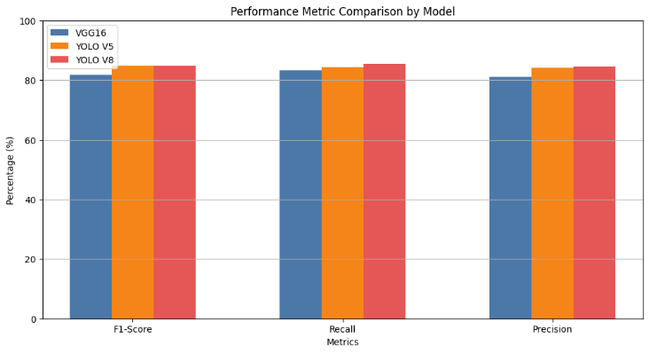

**Figure 2**: Statistics of trained model

# 7.Future Direction in Forensic Automation

The future of forensic automation holds immense potential for enhancing digital evidence analysis. One promising direction is the integration of artificial intelligence (AI) and machine learning (ML) into forensic tools. AI and ML can assist investigators in identifying patterns, anomalies, and relationships within vast datasets, enabling more accurate and efficient analysis [3]. As these technologies mature, they could significantly reduce the time required for investigations and improve the accuracy of automated findings.

Additionally, the development of advanced analytics and visualization tools can facilitate more intuitive exploration of complex data [4]. ForensicFlow could incorporate these capabilities, allowing investigators to generate visual representations of evidence, timelines, and connections, thus improving the clarity and impact of their findings.

Collaboration between law enforcement agencies, academia, and private sector organizations will also be crucial in shaping the future of forensic automation. By fostering partnerships, stakeholders can share knowledge, resources, and best practices, leading to the development of more comprehensive and effective forensic solutions.

Furthermore, as the landscape of digital threats continues to evolve, ongoing research and development will be necessary to anticipate and counteract emerging challenges. This includes addressing the security of forensic tools themselves, ensuring they are resilient against cyber threats and can maintain the integrity of the evidence they process.

# 8.Integration with Forensic Flow

Data Processing: Images and videos taken at the scene can be ingested, preprocessed, and analyzed using YOLO.

Automated Analysis Workflow: ForensicFlow automatically marks important discoveries and can include them in the investigation workflow.

Security and Compliance: Leverage security mechanisms available in ForensicFlow, such as Role-Based Access Control, Zero Trust, to maintain the integrity of evidence.

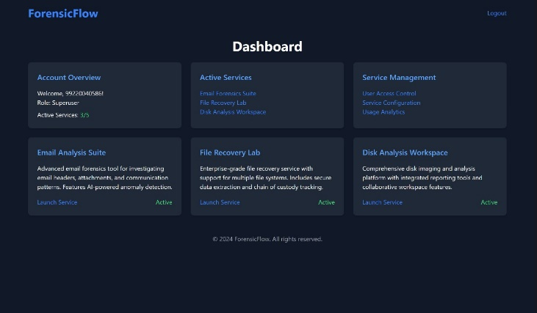

**Figure 2:**  Admin Dashboard

# 9.Conclusion

In conclusion, ForensicFlow: An Automated Digital Evidence Analysis Platform represents a significant leap forward in the field of digital forensics. By integrating powerful tools such as FTK Imager, Autopsy, and TestDisk, alongside robust security mechanisms like Role-Based Access Control, Zero Trust Network, and Least Privilege Access, ForensicFlow enhances the efficiency, accuracy, and security of forensic investigations. However, challenges such as the rapid evolution of technology, the risk of false positives, data privacy concerns, and the need for ongoing training must be addressed to maximize the platform’s potential.

In conclusion, by developing forensic technologies through machine learning and digital forensics, our initiative supports SDG Goals 9: Industry, Innovation, and Infrastructure and 16: Peace, Justice, and Strong Institutions. These developments improve crime scene analysis's accuracy and efficiency, facilitating quicker and more dependable evidence processing that aids the legal and law enforcement systems. The initiative enhances judicial systems and makes communities safer and more resilient by incorporating state-of-the-art technology into forensic techniques. The significance of our efforts to advance justice, security, and sustainable infrastructure in the field of forensic science is highlighted by this alignment with the SDGs.

**REFERENCES**

1. Carrier, B. (2005). "File System Forensic Analysis." Addison-Wesley.
2. Kahn, M. (2013). "Digital Forensics for Network, Internet, and Cloud Computing." Syngress.
3. McKemmish, R. (1999). "What is forensic computing?" Computer Law & Security Report, 15(2), 116-126.
4. OWASP Foundation. (2021). "OWASP Top Ten."
5. Shinder, D. (2011). "Computer Forensics: A Pocket Guide." Syngress.
6. Valli, C., & Mistry, A. (2015). "Digital Forensics: Concepts, Techniques, and Applications." Springer.
7. Wang, L., & Li, Z. (2019). "Digital Forensics: A Comprehensive Overview." CRC Press.
8. Wiles, J. (2015). "Computer Crime Investigation: A Comprehensive Guide." Academic Press.
9. Dutta, A.K., Elhoseny, M., Dahiya, V., Shankar, K, 2020,An efficient hierarchical clustering protocol for multihop Internet of vehicles communication, Transactions on Emerging Telecommunications TechnologiesVolume 31, Issue 5, 1 May 2020, Article number e3690.
10. P. Velmurugadass, S. Dhanasekaran, S. Shasi Anand, V. Vasudevan, Enhancing Blockchain security in cloudcomputing with IoT environment using ECIES and cryptography hash algorithm, https://doi.org/10.1016/j.matpr.2020.08.519
11. K. Venkatesh, An energy efficient computational task offloading and resource allocation for mobile edge computing for environmental applications, Journal of Environmental Protection and Ecology, 2023, Vol. 24, Issue 6, pp. 2183–2194. https://scibulcom.net/en/article/BtEpdGqxwoZCvTxYKESr
12. K. Venkatesh, Moving Object Detection and Tracking Algorithm Using Hybrid Decomposition Parallel Processing, Intelligent Automation & Soft Computing. 2022, vol. 33, no.3, pp. 1485–1499, 2022. <https://doi.org/10.32604/iasc.2022.023953>.
13. Casey, E., Ferraro, M., & Nguyen, L. (2009). **Digital Evidence and Computer Crime: Forensic Science, Computers and the Internet** (3rd ed.). Academic Press.
14. Jang, J., & Woo, H. (2020). **Artificial Intelligence in Digital Forensics: From AI Models to Practical Applications**. *IEEE Access*, 8, 151327-151344.
15. Latour, B., & Woolgar, S. (2021). **Forensics and SDG 16: Bridging Innovation with Justice**. *Journal of Sustainable Development Studies*, 14(1), 45-61.